error

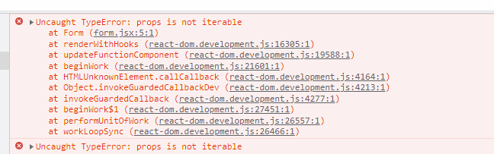

Cause – square brackets used for props instead of curly brackets

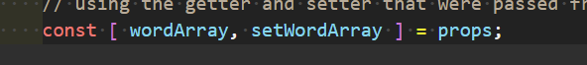

Fixed

